

PYTHON PROGRAMMING
(355)

NATIONAL 2024

APPLICATION KNOWLEDGE:
NationalPython (600 points)

TOTAL POINTS (600 points)

INDUSTRY CERTIFICATION (50 minutes)
IT Specialist Python Certification

Test Time: 90 minutes

GENERAL GUIDELINES:
Failure to adhere to any of the following rules will result in disqualification:

- No equipment, supplies, or materials other than those specified for this event are allowed in the testing area. No previous BPA tests and/or sample tests (handwritten, photocopied, or keyed) are allowed in the testing area.

- Electronic devices will be monitored according to ACT standards.

- Once you have completed all four jobs listed below, upload all competition materials (including project files, etc.) to the National BPA Pre-submit System at presubmit.bpa.org.

- Compress all files in a single archive (zip file) and use the following:

PYTHON-MemberID.zip

Assumptions to make when taking this assessment:

- Your program will be reading from a single text file that will be used to create two different types of objects. The text file contains information for the records using a ‘,’ (comma) as a delimiter. A single letter will be used to determine which type of object to create.
- Both types of objects will use a parent class that they will inherit behaviors and attributes.
- The program will prompt the user if they wish to perform four different actions. One of the actions gives the user the ability to end the program.
- The txt file for creating the objects in question have been provided (InventoryText.txt). Given the complexity of the project, you will have access to a single Python file that will contain all of the classes needed to complete the task. It is not necessary to store object classes as their own file; however, if you choose to do so, there is no penalty.
- The output in console needs to be as close as possible to the example provided. Minor deviations that have no impact on the output formatting, calculations, or reading of the txt files will have no penalty. However, your console output from the reading the txt file and the user input and output must be exact.

Development Standards:

- Your Code must use a consistent variable naming convention.
- All subroutines (if any), functions (if any), and methods (if any) must be documented with comments explaining the purpose of the method, the input parameters (if any), and the output (if any). Readability is a goal of good code.

Commenting for Source Code Review (see the rubric):
- Certain sections of your code will be graded. These gradable blocks of code can range from creating data structures, method algorithms, exception handling, and class construction.
- The grading rubric contains a section called Source Code Review: in this section are listed a description all of the graded programming concepts.
- Each gradable item must have a comment listed at its beginning, and the comment must be prefixed with the comment flag. The flag helps the graders easily locate the code to increase the effectiveness of grading.
- The flag will always use this naming convention: SC# (NOTE: the # symbol will be replaced with sequential numbering, i.e. SC1, SC2, SC3, etc.
- No explanation in the comment with the flag is required, only the comment flag; however, any information placed in the comment could help the grader better understand and avoid any costly errors.
- The comment flag needs to be place in close proximity to the block of code it represents.
- If a comment flag is not present, you will not receive credit.
- In this example the Source Code Review has a gradable section of code for printing to the console (Remember these are non-related examples):
  - SC12: print method in the main class is printing the correct object ____ 10 pts
  - The user will place the code above the method call:

#SC12 printing the car object
print(car)

NationalPython

In this test you will be creating a simple inventory management program for a food company that creates pizza and pasta for other food chains. The program you will create is an entry level prototype that is intended to read a txt file that stores exported database records as a single line of text. Each field of the record is separated by a comma. In the txt file, there is a flag set as a single letter to help the program to determine if the record it is about to read will be categorized as pizza or pasta. The subsequent information after this flag will be the properties of the record such as its SKU symbol, name, price, and how many units exist in the warehouse.
Input
You program will read the file, determine if the record is for pizza or pasta, create the appropriate object, and store both objects into a single data structure (Hint: a list is ideal). Once the records are stored, the program will prompt the user if they would like to perform one of four actions by typing the desired action into the console. The following are the input actions from the user:
- CREATE: prompts the user to create more pizza/pasta and will ask how many they want to create.
- DISTRO: this is short for “Distribution”, which allows the user to distribute the pizza/pasta to a third party. The program will ask which product to distro and how many. The user cannot distro more than they have in the warehouse.
- LIST: this command allows the user to see what products are in their inventory.
- END: this command will terminate the program.

Output
The output for the program will be dependent on the codes ability to read the txt file. Listed below are examples of what the output will entail from information being pushed to console, and from user interaction. User input is not case sensitive however the program should check for entry errors such as wrong symbols, entering letters instead of numbers, or entering values beyond the defined upper and lower boundaries. The “CREATE” and “DISTRO” pathways are almost identical in terms of output and prompts so only one will be displayed.

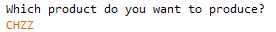
STEP 1 Create: accepts UC or LC entries.
STEP 2 Product Symbol: accepts UC or LC entries.
STEP 3 Inventory Units to Create: accepts whole numbers only.
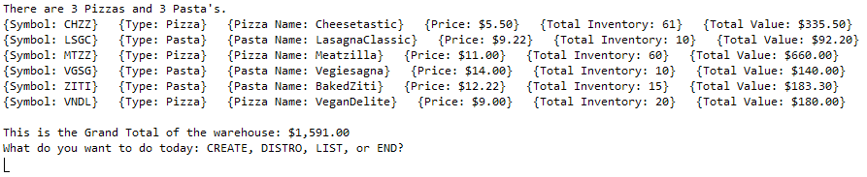
STEP 4 List and Update Values. NOTE: any inventory adjustments via create and distro should be reflected in any calculations. In this example we created inventory for CHZZ so its Inventory, Total Value, and the Grand Total for the warehouse increased.
STEP 1 Distro: accepts UC or LC entries.
STEP 2 Product Symbol: accepts UC or LC entries.
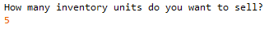
STEP 3 Inventory Units to Distro: accepts whole numbers only less than the inventory total for the specific product type.
STEP 4 List and Update Values. This step is same compared to Create and a list is automatically created with updated values and calculations.

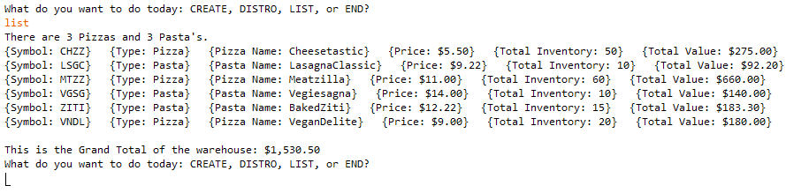
STEP 1 List: accepts UC or LC entries and displays the output list as previously shown.
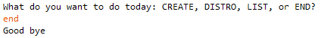
STEP 1 End: Program exits with goodbye message.
NOTE: The STEPS 1-4 keep repeating until the user enters “End” command on STEP 1.

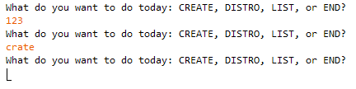
STEP 1 Error: program will force the user to correctly enter one of the commands. See image to the right.
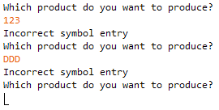
STEP 2 Create/Distro Error: program will force the user to correctly enter one of the product symbols. See image to the left.

STEP 3 Inventory Units Create/Distro Data Value & Range Violation Error: program will force the user to correctly enter the correct data value and a number within the range. See images below.

File Not Found: if the file is not found the program will display the following message and exit. See image below.
Requirements
- You will be creating all of your classes and methods in a file called main.py. The only other file in the folder will be the InventoryText.txt file.
- Your contestant number must appear as a comment at the top of the main.py source code file.
- A parent object class called InventoryProductsTypes has been given to you except for its constructor that has four arguments: String (Symbol), String (Name), Integer (Price), Integer (Inventory). You will need to create this.
- You will use inheritance to create two children classes of this class called Pasta and Pizzas. These classes will be used to create objects from the records being read.
- The methods in Pastas and Pizzas classes will almost be the same as its parent class; however, you will NEED to program the constructor (four arguments) and the __str__ method for both of these classes to create the desired output as seen in the listing (see the Output section). In addition, the __str__ will need to format the Price field and the Total Value field for United States currency.
- The Warehouse class will run the program once the DRIVER SECTION reads the file.
- You must implement these methods in the Warehouse class:
  - createPizza and createPasta methods: these will instantiate the appropriate objects and assign them to a data structure. These are called from the DRIVER SECTION.
  - getCommand method: used to check what the user enters in the command prompt. The user commands are not case sensitive. The user must enter in a correct command. User input is NOT case sensitive. Hint: STEP 1.
  - letsCreate method: CREATE entry from the user prompts the program to call this method which will create more products for the inventory. Method should force user to enter in correct values. Once finished, this method calls transaction. Hint: STEP 2 & 3.
  - letsDistro method: this does the same thing as letsCreate but it prompts the user to prepare to sell specific products. It will also call transaction method. Hint: STEP 2 & 3.
  - transaction method: this method will determine to either to create (add) more products or to distro (subtract) from those specific products. Remember to update inventory values for each object. Hint: STEP 3.
  - getWarehouseTotalValue method: calculates and returns grand total of all inventory. Hint: STEP 4
  - getWarehouseList method: prints the list for all of the inventory as seen in the Output section above. Remember to format for currency. Called from getCommand and can be called from transaction since after STEP 3 the program automatically prints the list to console. Hint: STEP 4.
  - symbolEntryVerification method: checks user symbol entry if it matches record symbol. This should be called from any where you need to verify if the user entered the correct product symbol. Called from letsCreate and letsDistro.
  - dataEntryVerifications method: checks that user entered in correct values for create ( 0 < x <= 1000) or distro ( 0 <x <=InventoryTotal or specific product). Called from letsCreate and letsDistro.
- DRIVER SECTION: This section is neither a method or a class, this will be the section that drives the program when it starts.
  - Its primary goal will be to read the InventryText.txt file, determine if the product is a Pasta (record will start with an ‘a’ or ‘A’) or Pizza (record will start with an ‘p’ or ‘P’).
  - It will call the Warehouse class methods createPasta or createPizza to construct the objects.
  - At the bottom of this section will be a call to the Warehouse method getCommand(given).
  - It will also need to detect if the file is present.
Your application will be graded on the following criteria: (NOTE: all input can be uppercase or LC)
Solution and Project
The project is present on the flash drive ____ 20 pts
The main.py and InventoryText.txt file are all in one folder ____ 10 pts
Program Execution
Code copied to USB drive and the program runs from USB ____ 10 pts
If the program does not execute, then the remaining items in this section receive a score of zero.
STEP 1: user is prompted if they like to CREATE, DISTRO, LIST, or END? ____ 10 pts
Entering “End” in LC or UC causes program to terminate ____ 20 pts
Upon ending the program tells the user “Good bye” ____ 10 pts
STEP 1: Entering “List” will list the inventory items exactly as the output ____ 40 pts
The listing begins with a total count of # of pizzas and # of pastas ____ 10 pts
The listing ends with total value of the warehouse ____ 10 pts
After listing, program asks uses for another command ____ 10 pts
STEP 1: Entering “Create” will prompt for product to produce ____ 20 pts
STEP 2: Entering product symbol in LC or UC will prompt number to create
and entry errors are handled, user forced to enter correct information ____ 10 pts
STEP 3: User cannot enter letters/symbols, and cannot create more than 1000 or less
than equal to 0 and cannot enter letters ____ 20 pts
STEP 4: After number to create is entered, program updates list (Total Inventory,
Total Value and Total value of warehouse) and displays it in console
and prompts for the next command from the user ____ 20 pts
STEP 1: Entering “Distro” in LC or UC will prompt for product to distro ____ 20 pts
STEP 2: Entering product symbol in LC or UC will prompt number to sell
and entry errors are handled, user forced to enter correct information ____ 10 pts
STEP 3: User cannot sell 0 or an amount greater than the total
inventory for the product and cannot enter letters ____ 20 pts
STEP 4: After number to create is entered, program updates list (Total Inventory,
Total Value and Total value of warehouse) and displays it in console
and prompts for the next command from the user ____ 20 pts
STEP 1: Errors entries are handled and forces user to enter correct command ____ 10 pts

Subtotal Points: _________/300pts

Source Code Review
NOTE: you must place the comment flag in front of the comment in your code in order to get credit. The comment flag will precede the explanation. For example, if the flag is SC1, your comment must read as “#SC1…” in front of the part of the code being reviewed. Code must work to get credit.
SC1: __str__ in Pastas has money value formatted in US currency ____ 10 pts
SC2: __str__ in Pizzas has money value formatted in US currency ____ 10 pts
SC3: Text file reading code in #DRIVER SECTION uses try/except
to detect if file is not found ____ 30 pts
SC4: letsCreate in Warehouse uses try/except to catch non numbers
being entered for number to create ____ 20 pts
SC5: letsDistro in Warehouse uses try/except to catch non numbers
being entered for number to create ____ 20 pts
SC6: getCommand in Warehouse is used to get user input for ALL
commands ____ 30 pts
SC7: getWarehouseTotalValue in Warehouse gets total value of warehouse ____ 10 pts
SC8: getWarehouseList in Warehouse is used to print entire list output and
format logical manner and formats total warehouse value US currency ____ 30 pts
SC9: transaction in Warehouse is used to determine if the program
needs to create or distro ____ 20 pts
SC10: symbolEntryVerification in Warehouse is used to determine if the symbol
is in the list ____ 20 pts
SC11: dataEntryVerification in Warehouse is used to determine if the symbol
is in the list ____ 20 pts
SC12: Pastas uses inheritance from InventoryProductsTypes ____ 20 pts
SC13: Pastas uses * to pass multiple arguments to its constructor as one variable ____ 20 pts
SC14: Pizzas uses inheritance from InventoryProductsTypes ____ 20 pts
SC15: Pizzas uses * to pass multiple arguments to its constructor as one variable ____ 20 pts

Subtotal Points: _________/300pts

Total Points: _________/600pts

